WARNING/ADVICE
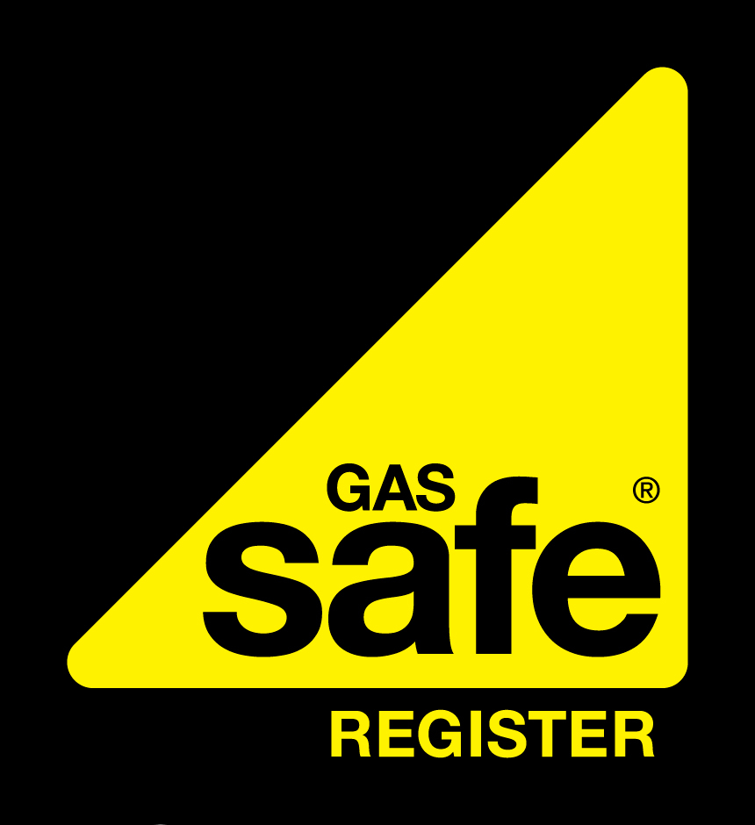
To confirm the validity of the Registered Gas Engineer please contact Gas Safe on 0800 408 5577 or www.gassaferegister.co.uk
COMPANY NAME  Gas Safe Reg No: 00000  W: WEB E: EMAIL  Job Number: | INSPECTION ADDRESS |  |  |  | AGENT/LANDLORD DETAILS (if different)
 | Name: |  |  |  | Name/Company:
 | Address: |  |  |  | Address:
 | Postcode:
 | Date: |  |  |  | Postcode:
 | Is accommodation rented? YES |  | NO |  | Tel. No:

Information contained in the boxes below is relevant to your safety
ESCAPE OF GAS
An escape of gas has been detected on the installation/appliance. The supply of gas has been disconnected.
This GAS APPLIANCE |  | OR |  | INSTALLATION PIPEWORK
MAKE: |  |  | MODEL:
TYPE: |  |  | SERIAL ID:
LOCATION: |  |  | ASSET NUMBER:
HAS BEEN CLASSIFIED AS :
IMMEDIATELY DANGEROUS |  | OR |  | AT RISK
REASON: |  |  |  | REASON:
For your own safety and the safety of others appliances classified At Risk or Immediately Dangerous should not be used
You have given consent for the appliance/installation to be disconnected from the supply of gas.
A Warning Label has been attached.

 |  | OR
You have not given consent for the appliance/installation to be made safe.
A Warning Label has been attached.

This GAS APPLIANCE |  | OR |  | INSTALLATION PIPEWORK
MAKE: |  |  | MODEL:
TYPE: |  |  | SERIAL ID:
LOCATION:
HAS BEEN CLASSIFIED AS :
NOT TO CURRENT STANDARDS
REASON:
This appliance/installation is currently in working order. It is not categorised either Immediately Dangerous or At Risk. While the defects found are not currently a gas safety hazard, in the interests of safety it is highly recommended that works be undertaken to bring the installation to current standards.
I have received this Warning/Advice Notice. I understand having been advised, that to use an appliance/installation categorised as Immediately Dangerous or At Risk presents a safety hazard which would place me in breach of the current Gas Safety (Installation and Use) Regulations.

Engineer | Name |  |  |  | Signature
No gas user was in attendance at the time of the inspection. Where necessary the installation/appliance was made safe. A copy of this Warning/Advice was left at the inspection location.


This form must be used in accordance with the current Gas Industry Unsafe Situations Procedure. It is a requirement by law for GAS SAFE registered engineers to report cases where they are refused permission to disconnect an IMMEDIATELY DANGEROUS gas installation to the Gas Emergency Service Contact Centre for Natural gas, or for Liquefied Petroleum Gas (LPG), your Gas Supplier. All Gas Transporters (GT’s) operate a gas emergency service and have powers under the Gas Safety (Rights of Entry) Regulations to visit properties and disconnect unsafe gas appliances/installations.

This form must be used in accordance with the current Gas Industry Unsafe Situations Procedure. It is a requirement by law for GAS SAFE registered engineers to report cases where they are refused permission to disconnect an IMMEDIATELY DANGEROUS gas installation to the Gas Emergency Service Contact Centre for Natural gas, or for Liquefied Petroleum Gas (LPG), your Gas Supplier. All Gas Transporters (GT’s) operate a gas emergency service and have powers under the Gas Safety (Rights of Entry) Regulations to visit properties and disconnect unsafe gas appliances/installations.

